**Mr. Reall’s Social Studies Class**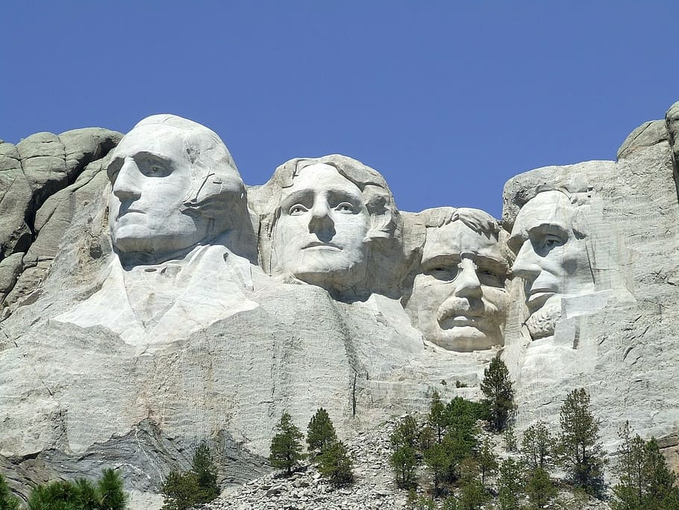

**Contact Information**

[wreall@bigspringsd.org](mailto:wreall@bigspringsd.org) [wreall@bigspring.k12.pa.us](mailto:wreall@bigspring.k12.pa.us)

**Classroom Rules**

Tolerance and respect are key elements in building a classroom environment where all students have a safe space to learn and succeed. For this classroom to succeed we all will….

1. Be Respectful. Not everyone will agree and we must respect others’ opinions.
2. Come prepared daily: Have a charged computer and charger for every class.
3. Follow school and classroom rules and expectations.
4. Give your full attention to the speaker (teacher OR student).

**Classroom Policies**

1. Remain in your seat with all materials unless directed otherwise.
2. Ask and sign out before leaving (bathroom breaks) and keep all trips quick and quiet.
3. **Absolutely no bullying (physical, emotional, or cyber) will be tolerated**. Keep your hands/feet to yourself.
4. Raise your hand to ask questions or answer questions unless told otherwise. Do not speak or make noise when others are speaking or listening.

**Consequences**

The following are possible consequences for breaking classroom rules or policies. This is just a general outline; **I reserve the right to start consequences at a higher level depending on the severity of the infraction.**

1. Warning about behavior, can be verbal or nonverbal
2. Stay after class to discuss behavior
3. Sit in desk in hall/5m or move seat for the day
4. Last to lunch/2m- on next cycle day we meet, students need to remember
5. Contact parents/guardians/home
6. Office Referral/Lunch detention, after school detention or ISS based on Admin decision.



**Grading**

The school’s grading scale will be used for this class. Points are based on:

1. Performance Tasks / Tests and quizzes 65%
2. Classwork 35%

8th Grade Social Studies Gradebook Categories and Descriptions

### PTTQ (Performance Tasks and Tests/Quizzes) 65%

Students are able to make up, do corrections, or finish a PT, TQ at any point before the end of the marking period. Performance Tasks are designed for students to be assessed on State and Federal standards and the Profile of a Graduate as identified by the Big Spring School District. Evidence of growth and comprehension are necessary in order to pass a performance task/assessment. Performance Assessments and Tasks may be individual or group based, however every student will have an individual component and score based on their individual understanding and performance. Most Tests/Quizzes will be conducted electronically. Students are expected to have a charged chromebook in order to take their assessments. Students may have the opportunity to do corrections to their assessments if they wish. To do so they must contact their teacher and ask for information regarding corrections and a due date. Students who receive accommodations for testing and assessments will continue to receive such accommodations. If a student wishes to have their test taken in a different setting this must be pre-arranged with the teacher in order to make sure that an alternative setting and proctor is available.

### CW (Classwork) 35%

Students may ask to redo an assignment (may be redone on a case by case basis). Students have either 2 weeks from the due date or from their point of return to class to submit the assignment unless otherwise pre-arranged with the teacher. Points may be deducted for work submitted late without reason.

**Academic Dishonesty (Cheating)**

Your work shows what you have learned. It is a product of your effort and time. The school’s academic dishonesty policy protects your work and makes sure your work represents what you have learned. When a test or quiz is out, you may not be talking. Such talking will be treated as academic dishonesty. Students will lose credit for the assignment, test, or project if they cheat. Parents/guardians will also be contacted.

**Missed Classes**

It is the student’s responsibility to come talk to me after an absence (**communicating absences ahead of time is appreciated**). All materials are posted on the group Google Classroom page. It is your responsibility to complete missing work within a timely manner. Mr. Reall is not responsible for any missing grades or material without communication from the student.

**Communication**

I am here to help you grow and learn as both a student and a young adult. If at any time you have a question or concern that you would like to talk about feel free to communicate with me in any manner that you can (email, face to face, notes, etc.)

**8th Grade American History/Studies Course Outline**

Unit/Quarter 1: Early exploration and the Colonies: Review of Geography and introduction of European Explorers and the exploration and identification of the Western Hemisphere and Continents. Foundation of early Colonial Settlements and the start of Global trade.

Unit 2/Quarter 2: Revolution and Founding Philosophies: Identification of early conflicts that set the stage of independence of the United States from colonial rule. Gaining basic understanding of the United States governmental structure and how and why it was formatted in its current structure. Creating familiarity with the Constitution, Bill of Rights, and other foundational documents.

Unit 3/Quarter 3: Westward Expansion: Focus on identifying growth factors within the newly formed United States and the need for territorial expansion. Students continue to grow their knowledge of the 50 states and regions within the country. Further instructional focus is on the impact of westward expansion on indigenous groups and the setters themselves.

Unit 4/Quarter 4: The Civil War: Students focus on the differences in the evolution of society in the different regions of the United States and how it led to conflict among these regions as the country continued to expand and develop. The Industrialization, Format of Society, Religious and Early Civil Rights as well as other Political Movements are explored. The impact of these movements are then applied to the Civil War which is identified in three main phases. The course ends with Reconstruction and the creation of the Civil Rights Amendments.

**The syllabus is subject to change as needed per the teacher.**

**Thank you for reading this and your support during the school year, Mr. Reall.**